SingletonMethod:---

Logger.java code—

package singleton;

public class Logger {

// Step 1: Private static instance variable

private static Logger *instance*;

// Step 2: Private constructor to prevent direct instantiation

private Logger() {

System.***out***.println("Logger instance created");

}

public static Logger getInstance() {

if (*instance* == null) {

*instance* = new Logger();

}

return *instance*;

}

public void log(String message) {

System.***out***.println("Log: " + message);

}

}

LoggerTest.java code-package singleton;

public class LoggerTest {

public static void main(String[] args) {

Logger logger1 = Logger.*getInstance*();

logger1.log("First log message.");

Logger logger2 = Logger.*getInstance*();

logger2.log("Second log message.");

if (logger1 == logger2) {

System.***out***.println("Both logger instances are the same (singleton works).");

} else {

System.***out***.println("Different instances (singleton failed).");

}

}

}

OUTPUT--Logger instance created

Log: First log message.

Log: Second log message.

Both logger instances are the same (singleton works).

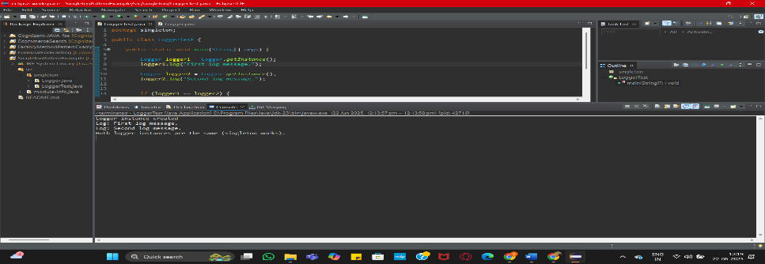

FactoryMethodPattern----

Document.java--package com.shreya.documents;

public interface Document {

void open();

}

DocumentFactory.java---package com.shreya.documents;

public abstract class DocumentFactory {

public abstract Document createDocument();

}

ExcelDocument.java---package com.shreya.documents;

public class ExcelDocument implements Document {

*@Override*

public void open() {

System.***out***.println("Opening an Excel document.");

}

}

ExcelDocumentFactory.java---package com.shreya.documents;

public class ExcelDocumentFactory extends DocumentFactory {

*@Override*

public Document createDocument() {

return new ExcelDocument();

}

}

PdfDocument.java---package com.shreya.documents;

public class PdfDocument implements Document {

*@Override*

public void open() {

System.***out***.println("Opening a PDF document.");

}

}

PdfDocumentFactory.java---package com.shreya.documents;

public class PdfDocumentFactory extends DocumentFactory {

*@Override*

public Document createDocument() {

return new PdfDocument();

}

}

WordDocument.java----package com.shreya.documents;

public class WordDocument implements Document {

*@Override*

public void open() {

System.***out***.println("Opening a Word document.");

}

}

WordDocumentFactory.java--package com.shreya.documents;

public class WordDocumentFactory extends DocumentFactory {

*@Override*

public Document createDocument() {

return new WordDocument();

}

}

Main.java--package com.shreya.documents;

public class Main {

public static void main(String[] args) {

DocumentFactory wordFactory = new WordDocumentFactory();

Document wordDoc = wordFactory.createDocument();

wordDoc.open();

DocumentFactory pdfFactory = new PdfDocumentFactory();

Document pdfDoc = pdfFactory.createDocument();

pdfDoc.open();

DocumentFactory excelFactory = new ExcelDocumentFactory();

Document excelDoc = excelFactory.createDocument();

excelDoc.open();

}

}

OUTPUT

Opening a Word document.

Opening a PDF document.

Opening an Excel document.

